Open - <http://releases.ubuntu.com/16.04/>

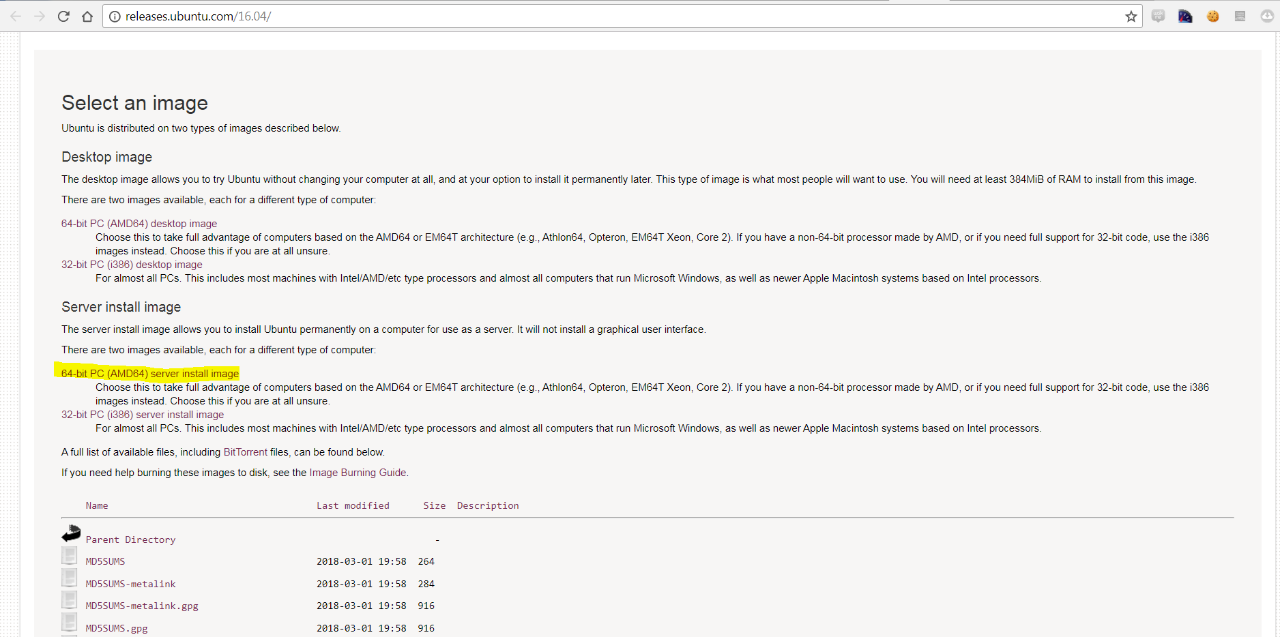

Click on above link to download ununtu iso image. Downloaded image file will have extension .iso, it may take 30 mins to download based on internet speed.

Download and Install software – Universal USB installer and then follow below instructions mentioned on this page - <https://itsfoss.com/create-live-usb-of-ubuntu-in-windows/>

It will take another 30 mins to create a bootable pen-drive.

Connect pen-drive to computer and restart the machine and then press F10 to allow you to select boot from pen-drive.

It will launch the Ubuntu screen and will ask for further installation.